COUNCIL ASSESSMENT REPORT

Panel Reference | PPSNTH-8
DA Number | 2019 - 546
LGA | Port Macquarie-Hastings
Proposed Development | Additions to Educational Establishment (Stage 2B Charles Sturt University Campus)
Street Address | 11 Ellis Parade, Port Macquarie
Applicant/Owner | Charles Sturt University CARE King & Campbell Pty Ltd
Date of DA lodgement | 2 August 2019
Number of Submissions | One(1) submission
Recommendation | Consent subject to conditions
Regional Development Criteria (Schedule 7 of the SEPP (State and Regional Development) 2011 | Crown development over $5 million
List of all relevant s4.15(1)(a) matters | - State Environmental Planning Policy No.44 – Koala Habitat Protection  - State Environmental Planning Policy No.55 – Remediation of Land  - State Environmental Planning Policy No.62 – Sustainable Aquaculture  - State Environmental Planning Policy No. 64 – Advertising and Signage  - State Environmental Planning Policy (Coastal Management) 2018  - State Environmental Planning Policy (Infrastructure) 2007  - State Environmental Planning Policy (Educational Establishments and Childcare Facilities) 2017  - State Environmental Planning Policy (State and Regional Development) 2011  - State Environmental Planning Policy (Primary Production and Rural Development) 2019  - Port Macquarie-Hastings Local Environmental Plan 2011  - Development Control Plan 2013
List all documents submitted with this report for the Panel’s consideration | - Development plans (as amended)  - Traffic and parking report & additional information  - NSW Roads and Maritime Services (RMS) advice (2 letters)  - Noise report  - Development contributions estimate - Notice of Payment  - Draft consent conditions as agreed to with Applicant (on behalf of Crown)
Report prepared by | Pat Galbraith-Robertson
Report date | 19 November 2019

Summary of s4.15 matters  Have all recommendations in relation to relevant s4.15 matters been summarised in the Executive Summary of the assessment report? | Yes
Legislative clauses requiring consent authority satisfaction  Have relevant clauses in all applicable environmental planning instruments where the consent authority must be satisfied about a particular matter been listed, and relevant recommendations summarized, in the Executive Summary of the assessment report?  e.g. Clause 7 of SEPP 55 - Remediation of Land, Clause 4.6(4) of the relevant LEP | Yes
Clause 4.6 Exceptions to development standards  If a written request for a contravention to a development standard (clause 4.6 of the LEP) has been received, has it been attached to the assessment report? | Not Applicable
Special Infrastructure Contributions  Does the DA require Special Infrastructure Contributions conditions (S7.24)?  Note: Certain DAs in the Western Sydney Growth Areas Special Contributions Area may require specific Special Infrastructure Contributions (SIC) conditions | Not Applicable
Conditions  Have draft conditions been provided to the applicant for comment?  Note: in order to reduce delays in determinations, the Panel prefer that draft conditions, notwithstanding Council’s recommendation, be provided to the applicant to enable any comments to be considered as part of the assessment report | Yes

RECOMMENDATION

That DA2019 – 546 for Additions to Educational Establishment (Stage 2B Charles Sturt University Campus) at Lot 1 DP 1240488 No. 11 Ellis Parade, Port Macquarie, be determined by granting consent subject to the recommended conditions (Attachment 1).

Executive Summary
This report considers a Development Application for Additions to an Educational Establishment (Stage 2B Charles Sturt University Campus) at the subject site. The proposal is a Crown Development.

Following exhibition of the application, one(1) submission has been received.

The proposal has been amended during the assessment of the application. The amendments primarily include changes made to the design of the carpark extensions, location of electrical substation and storm disposal arrangements.

Construction has commenced for Stage 2A (second building to north within site) of the expansion of the University.

Division 4.6 of Part 4 of the Environmental Planning & Assessment Act 1979 includes provisions relating to Crown development. Section 4.32 defines a reference to the Crown as:

(a) Includes a reference to a person who is prescribed by the regulations to be the Crown for the purposes of this Division

Clause 226(1)(c) of the Environmental Planning & Assessment Regulations 2000 provides that an Australian university within the meaning of the Higher Education Act 2001 is prescribed. CSU, the Applicant, is listed as an Australian University under Schedule 1 of the Higher Education Act 2001. As the development will be carried out by the University, the application is considered a Crown Development Application for the purposes of the Environmental Planning & Assessment Act, 1979.

In accordance with Section 4.33(1) of the Environmental Planning & Assessment Act 1979, the consent authority is the Northern Joint Regional Planning Panel (JRPP). The JRPP must not refuse its consent (except with the approval of the Minister) or impose a condition on its consent (except with the approval of the applicant or the Minister).

This report provides an assessment of the application in accordance with the Environmental Planning and Assessment Act 1979. The consent authority must be satisfied in relation to a number of provisions in relevant environmental planning instruments applicable to the proposal before granting consent to the development. A detailed assessment of the relevant clauses is noted within the report. A summary is also provided below:

- Parts 2 and 3 of SEPP No.44 – Koala Habitat Protection
- Clause 7 of SEPP No.55 – Remediation of Land
- Clause 13 of SEPP No.64 - Advertising and Signage
- Clause 11 of State Environmental Planning Policy (Coastal Management) 2018
- Clauses 34 and 104 of SEPP (Infrastructure) 2007
- Part 5 and clause 57 of State Environmental Planning Policy (Educational Establishments and Childcare Facilities) 2017
- Part 4 of State Environmental Planning Policy (State and Regional Development) 2011
- Clause 30 of State Environmental Planning Policy (Primary Production and Rural Development) 2019
- Clauses 2.2, 2.3, 5.10, 7.1, 7.3, 7.4 and 7.13 of Port Macquarie-Hastings Local Environmental Plan 2011

In summary, the assessment of the proposed development has adequately addressed all consent considerations required by the above environmental planning instrument clauses. The Joint Regional Planning Panel can proceed with determining the Development Application by granting consent, subject to the recommended conditions of consent.

1. BACKGROUND
Existing sites features and surrounding development
The site has an area of 11.8485 hectares and has frontage to existing public roads being Major Innes Road and Ellis Parade, Port Macquarie.

The land is zoned part R1 General Residential (occupied by Stage 1 building and car park), part B2 Local Centre (occupied by Stage 1 car park) and part RU1 Primary Production (being all of the land south of and including the unformed Council road reserve) in accordance with Port Macquarie-Hastings Local Environmental Plan 2011. The zoning and site identification is shown below:

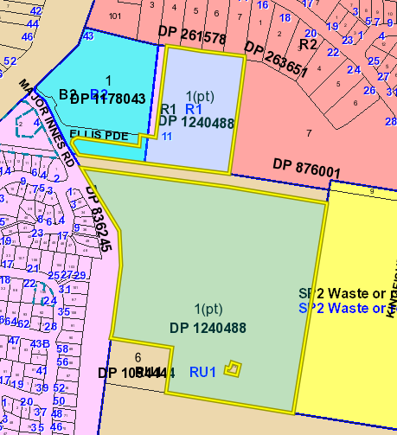

The proposed Stage 2B building, new access road and carpark is wholly contained within that part of the land zoned RU1 Primary Production however is associated with the remainder of the Stage 1 and 2A parts of the University.

The CSU campus is located approximately 5km south-west of the Port Macquarie CBD.

The CSU campus is identified in Council’s Urban Growth Management Strategy (UGMS) as being within a Health and Education Precinct. The campus is situated approximately 600m south of the Port Macquarie Base Hospital and is adjacent to the Lake Innes Village Shopping Centre. A student accommodation development and Council’s Kingfisher Road Waste Transfer Station and previous waste landfill site adjoin the eastern boundary of the campus.

St Columba Anglican School is located to the south. The land is bounded by Major Innes Road to the west, with residential subdivision located on the western side of Major Innes Road.

Stage 1 of the CSU campus was approved in 2014 under DA 2014 - 119 and DA2014 - 120. The Stage 1 approval provided for a building group comprising 7,600m2 around a central courtyard. The approval also provided for the associated vehicle and bicycle parking.

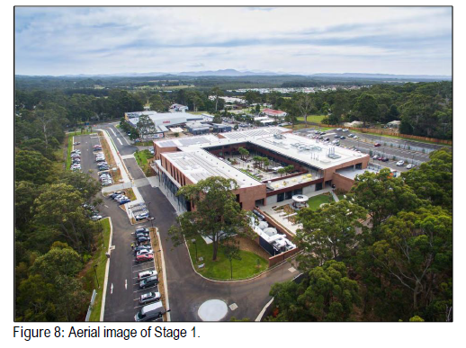

The permanent campus commenced operation in February 2016.

A recent aerial image of the campus and surrounding uses is provided below. The image identifies the CSU land and shows the Stage 1 building and 2A building under construction and the adjoining Student Accommodation development:

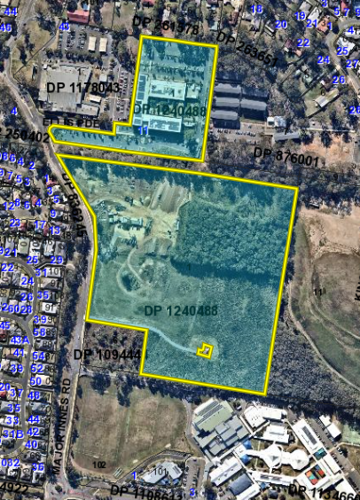

Stage 2A of the campus was approved in 2019 in DA 2018 - 834 and is currently under construction. Stage 2A provides for the northern wing of the next courtyard building group and includes 2,935m2 of gross floor area and associated works.

At the completion of Stage 2A the campus will comprise a Gross Floor Area of approximately 10,564m2 (which includes teaching areas totalling 3,311m2) together with 423 car parking spaces. The campus will cater for an Equivalent Full Time Student Load (EFTSL) of approximately 1,500 students (being total
enrolments of between 1,800 and 1,875) and 170 staff.

The campus layout, including Stage 2A, is shown below:

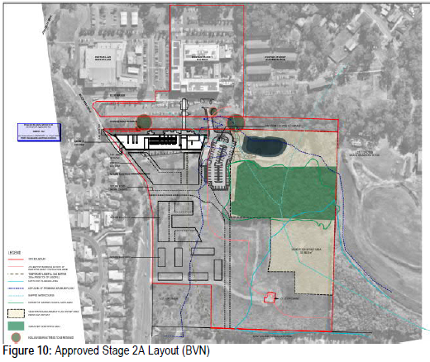

The Applicant has advised that projections to 2023 indicate that staff and student numbers are expected to increase to 175 and 2,500 (enrolments) in 2023. This projection reflects the expanding course profile offered at the campus, the increase in international student numbers and the current growth rates.

A Koala Plan of Management (KPoM) was prepared and approved by Council and the Department of Planning as part of the Stage 2A development. In addition, the Vegetation Management Plan (VMP) was amended as part of the approval process to account for the minor extension of the Stage 2A car park in to the Southern Offset Area (Version 1 August 2018). The Southern Offset Area remains 3.59 Ha in size.

2. DESCRIPTION OF DEVELOPMENT
Key aspects of the proposal as shown in Attachment 2, as amended, include the proposed expansion of the existing Charles Sturt University campus and is known as Stage 2B.
The proposed Stage 2B Building and Associated Works include:
- A two (2) storey teaching, learning and administrative building comprising Gross Floor Area of 1,407m2 (654m2 of teaching space) together with verandahs and a rooftop photovoltaic electricity generating system;
- Hard and soft landscaping to support the proposed building, including an open lawn area and new pedestrian linkages to Major Innes Road;
- A car park comprising an additional 88 car parking spaces (nett spaces) to support the proposed building, including 2 accessible spaces;
- An intersection with Major Innes Road including a left turn deceleration lane in to the site for southbound movements and widening on the western side of Major Innes Road to provide for a protected right turn lane in to the site for northbound movements;
- A 7m wide private road network connecting Stage 2A and the proposed Stage 2B car park with the intersection at Major Innes Road;
- A new stormwater management facility;
- Water, sewer and electrical service connections from existing infrastructure on or adjacent to the land; and
- Entry walls on both sides of the proposed new access road incorporating CSU’s logo, up-lighting and flagpoles, similar to that in place on the corner of Major Innes Road and Ellis Parade.

The proposed Stage 2B building and associated works has a Capital Investment Value (CIV) of $17,888,000.
The application is a Crown Development Application and is also a Regionally Significant Development.

Application Chronology
- 25 June 2019 - Pre-DA lodgement meeting with Council staff.
- 2 August 2019 - DA lodged with Council.
- 6 August 2019 - Referral of DA to the NSW Roads and Maritime Services (RMS) for comment.
- 15 August to 13 September 2019 – Neighbour notification and public advertising.
- 28 August 2019 - Advice received from the RMS.
- 29 August 2019 - RMS advice forwarded to Applicant for consideration.
- 9 September 2019 - Crime risk prevention report received from Applicant.
- 20 September 2019 - Additional information requested from Applicant - roads and engineering issues.
- 24 September 2019 - Meeting with Applicant to discuss assessment issues.
- 4 October 2019 - Additional information and amended plans received.
- 18 October 2019 - Additional information and amended plans received.
- 29 October 2019 - Amended proposal and additional information referred to RMS for comment.
- 12 November 2019 - Draft conditions forwarded to Applicant/Crown to agree to.
- 13 November 2019 - Estimate of development contributions sent to Applicant.
- 15 November 2019 - Second advice received from the RMS.
- 15 November 2019 - Feedback on draft conditions received from Applicant.
- 15 November 2019 - Revised draft conditions sent to Applicant for review.
- 16 November 2019 - Applicant advised acceptance of draft conditions.
- 19 November 2019 - Additional information received from Applicant in regards to RMS advice.

3. STATUTORY ASSESSMENT
State Environmental Planning Policy No. 44 - Koala Habitat Protection
Pursuant to the provisions of Clause 6, the subject land is greater than 1 hectare, and therefore this policy applies to this application.
In accordance with the provisions of this SEPP, a Plan of Management was approved by Council and the Department of Planning as part of Stage 2A CSU development currently being constructed.
The KPoM considered the future loss of vegetation associated with the expansion of the campus, including the loss of the paddock trees anticipated to be removed as part of Stage 2B. On this basis, the Stage 2B is consistent with the approved KPoM and the requirements of this policy have therefore been addressed. An appropriate condition of consent is recommended to reinforce the obligations of the KPoM.
State Environmental Planning Policy No. 55 – Remediation of Land
This policy applies to the state. Pursuant to clause 7 of this SEPP, contamination and remediation are to be considered in the determination of any Development Application.
The Applicant has submitted a Limited Phase 2 Environmental Site Investigation undertaken by RCA Australia over the whole of the CSU land holding in 2013. The investigation concluded that the land is suitable for use as a university campus.
The development assessment processes for Stage 1 and Stage 2A of the campus have previously considered this matter.

As part of the construction of Stage 2A of the campus, a report by The Environmental Protection Group Pty Ltd of May 2019 (EPG report) has further reviewed the information available with respect to land fill gas, including recent monitoring.

This EPG report has been provided to Council as part of the implementation of the Stage 2A consent. The report has concluded that no specific gas mitigation is recommended beneath the floor slab construction for Stage 2A.

In addition to the above, it is noted that the proposed Stage 2B building is located further from the landfill than the approved Stage 2A building and is wholly outside of the temporary 250m buffer originally identified by GHD in its 2016 report.

Based on the findings of the Environmental Protection Group Pty Ltd report, current conditions on the Stage 2A building under DA2018 - 834 and the location of the Stage 2B building on the site, no further consideration of landfill gas is necessary for this application.
On this basis, the requirements of this SEPP have been satisfactorily addressed.
State Environmental Planning Policy No. 64 – Advertising and Signage
The application seeks consent for business identification signage on the two (2) proposed entry walls on either side of the new access road at the intersection with Major Innes Road. This is intended to be similar to that in place on the corner of Major Innes Road and Ellis Parade.
The business identification signage consists of the name Charles Sturt University together with the university’s logo. It is intended that the signage will be up-lit by ground level lighting.
Clause 8 of the policy requires that a consent authority must not grant development consent to an application to display signage unless the consent authority is satisfied:
(a) that the signage is consistent with the objectives of this Policy as set out in clause 3 (1) (a), and
(b) that the signage the subject of the application satisfies the assessment criteria specified in Schedule 1.
An assessment of the relevant provisions identified above is provided in the table below.

Applicable clauses for consideration | Comments | Satisfactory
Clause 8(a) Consistent with objectives of the policy as set out in Clause 3(1)(a). | Signage for the proposed development is compatible with the future desired character of the locality and is considered appropriate for the site’s location within the Health & Education Precinct. The signage will offer effective communication and is of a high quality design and finish. | Yes
Schedule 1(1) Character of the area. | The area is identified to be within Council’s strategic planned Health & Education Precinct. The signs will be situated on an existing university campus which adjoins St Columba Anglican School and the Lake Innes Village shopping centre. | Yes
Schedule 1(2) Special areas. | The site does not adjoin areas of heritage, conservation or open space significance. The signs are not considered to detract from the residential subdivisions to the west as the residences orientation do not address Major Innes Road, with lots fronting internal roads and rear fences being presented to Major Innes Road. | Yes
Schedule 1(3) Views and vistas. | The proposed signs will not obscure important views or dominate the skyline. | Yes
Schedule 1(4) Streetscape, setting or landscape. | The scale and proportions of the proposed signs are appropriate for the location and area. The signs will improve the streetscape in the area by formally identifying the access to an important facility within the Health & Education Precinct. | Yes
Schedule 1(5) Site and building. | The scale and proportions of the proposed signs are appropriate for the development type and will compliment the building design. | Yes
Schedule 1(6) Associated devices and logos with advertisements and advertising structures. | Associated devices and logos with the advertisements will be limited. | Yes
Schedule 1(7) Illumination. | Illumination of the signage is to be limited to low level up-lighting. | Yes
Schedule 1(7) Safety. | Safety for the general public is not considered to be  compromised as a result of the proposed signage. | Yes
The proposal satisfies the applicable requirements of this SEPP.
State Environmental Planning Policy (Educational Establishments and Child care Facilities) 2017
The aim of this SEPP is to facilitate the effective delivery of educational facilities by: improving certainty and efficiency through a consistent planning regime; and simplifying and standardising planning approval pathways.

The Stage 2B building and associated works are permissible with consent within the boundaries of the existing university, being Lot 1 DP1240488, pursuant to clause 45 of this Policy.

Clause 57 ‘Traffic Generating Development’ applies to educational establishments that involve an enlargement or extension of existing premises on a site that has direct vehicular or pedestrian access to any road. The proposal has been referred to the Roads & Maritime Services under this policy. Comments addressing the feedback from RMS is addressed later in this report under Access, Transport and Parking.
State Environmental Planning Policy (Coastal Management) 2018 and Clause 5.5 of Port Macquarie-Hastings Local Environmental Plan 2011
The site is part mapped coastal wetlands and the development itself is located within a proximity area to those mapped wetlands.
In accordance with clause 11, this SEPP prevails over the Port Macquarie-Hastings LEP 2011 in the event of any inconsistency.
As shown in the below image, part of the subject land has been mapped as Coastal Wetland.
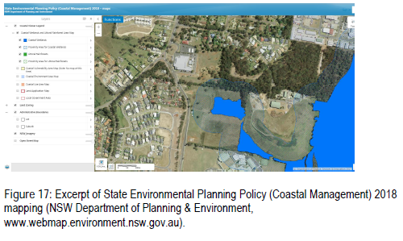
No work is proposed in the area recently mapped as Coastal Wetlands under this policy. Work is proposed in the location identified as ‘Proximity Area for Coastal Wetlands’.
The site is not located within a ‘coastal use area’ or ‘coastal environment area’.
Clause 11 requires consideration where development consent is being sought. In accordance with the provisions of the SEPP, where development consent is sought for work within the proximity area, the consent authority is to be satisfied that the development will not have a significant impact on the following:
(a) the biophysical, hydrological or ecological integrity of the adjacent coastal wetland or littoral rainforest, or
(b) the quantity and quality of surface and ground water flows to and from the adjacent coastal wetland or littoral rainforest.

The Applicant has provided satisfactory details that to ensure that the quantity and quality of the stormwater from the development does not impact on the mapped Coastal Wetland. In particular TTW consultants analysed the stormwater and ensured that the stormwater management plan complied with the design provisions of Port Macquarie-Hastings Council’s Design Specification D7: Stormwater
Management. TTW’s civil engineering report confirms that the measures included within the proposed design will ensure pollutant targets are met.

Furthermore, an assessment of ecological matters has been undertaken by SLR and includes the following comments:
“An Assessment of Significance, pursuant to s.7.3 of the BC Act, determines that the proposed development is unlikely to have a significant impact on threatened biota”

Based upon the above, the proposed works will not have a significant impact on the integrity of the adjacent mapped Coastal Wetland.

State Environmental Planning Policy (Infrastructure) 2007
Clause 104 of the Infrastructure SEPP relates to traffic generating development.

The clause applies to development listed in column 1 of the table to schedule that involves:
(a) new premises of the relevant size or capacity, or
(b) an enlargement or extension of existing premises, being an alteration or addition of the relevant size or capacity.

The proposal seeks consent for a new two storey teaching, learning and administration building and associated car parking.

The Stage 2B car park will comprise additional 88 car parking spaces (nett spaces) and together with the existing carparking which is above the car park threshold of 200 spaces.

The proposal has been referred to the Roads & Maritime Services under this policy on two occasions. Comments addressing the feedback from RMS is addressed later in this report under Access, Transport and Parking.

In addition, it is noted that the Stage 2B building will include a rooftop photovoltaic electricity generating system. Pursuant to Clause 34 of the SEPP the proposed system is permissible with development consent.
The roof top solar system proposed is suitably located and no adverse environmental impacts can be identified.

State Environmental Planning Policy (State and Regional Development) 2011
This policy aims to identify state and regionally significant development or infrastructure and confer functions on Joint Regional Planning Panels.

Clause 20 of this SEPP - regional development is triggered by the development. Schedule 7 identifies the development for which a regional panel is authorised to exercise the consent authority function.

Clause 4 of Schedule 7 reads as follows:

4 Crown development over $5 million Development carried out by or on behalf of the Crown (within the meaning of Division 4.6 of the Act) that has a capital investment value of more than $5 million.

The proposed Stage 2B CSU development has a Capital Investment Value of $17,888,000.

The proposed development meets Clause 4 as the proposal has an estimated construction value greater than $5 million and is Crown Development.

Clause 20 identifies the Northern Joint Regional Planning Panel as the consent authority. The purpose of this report is to provide an assessment of the Development Application in accordance with section 4.15 of the Act.

State Environmental Planning Policy (Primary Production and Rural Development) 2019
This SEPP applies to the Port Macquarie Hastings Local Government Area and aims to facilitate the orderly economic use and development of lands for primary production.

This SEPP also requires the consent authority to consider if any proposed development may have an adverse effect on oyster aquaculture development or a priority oyster aquaculture area.

The land is surrounded by urban land uses and the land is identified within Council’s Urban Growth Management Strategy 2017-2036 as being within the Port Macquarie health and education
precinct and the growth of the campus has been anticipated. The current RU1 zoning is not considered to be reflective of the current or planned use of the land. Agricultural activity is not considered to be compromised by the development.

The proposed development incorporates appropriate stormwater management facilities which will ensure that the discharge of stormwater from the land will meet the necessary quantity and quality standards. The proposed development is not likely to effect an oyster aquaculture development or a priority oyster aquaculture area.

Based upon the above, the requirements of this SEPP are satisfied.

Port Macquarie-Hastings Local Environmental Plan 2011
The proposal is consistent with the LEP having regard to the following:
- Clause 2.2 - The land is zoned partly R1 General Residential, part B2 Local Centre and part RU1 Primary Production in accordance with Port Macquarie-Hastings Local Environmental Plan 2011. The proposed Stage 2B development is located within the part RU1 zoned land but is associated with the remainder of the Stage 1 and 2A CSU campus. As detailed above, the ‘educational establishment’ is permissible with consent on the land pursuant to the provisions of Clause 45 of State Environmental Planning Policy (Educational Establishments and Child Care Facilities) 2017.

The objectives of the RU1, B2 and R1 zones respectively are as follows:

Zone RU1 Primary Production
1 Objectives of zone
• To encourage sustainable primary industry production by maintaining and enhancing the natural resource base.
• To encourage diversity in primary industry enterprises and systems appropriate for the area.
• To minimise the fragmentation and alienation of resource lands.
• To minimise conflict between land uses within this zone and land uses within adjoining zones.

Zone B2 Local Centre
1 Objectives of zone
• To provide a range of retail, business, entertainment and community uses that serve the needs of people who live in, work in and visit the local area.
• To encourage employment opportunities in accessible locations.
• To maximise public transport patronage and encourage walking and cycling.
• To ensure that new developments make a positive contribution to the streetscape and contribute to a safe public environment.

Zone R1 General Residential
1 Objectives of zone
• To provide for the housing needs of the community.
• To provide for a variety of housing types and densities.
• To enable other land uses that provide facilities or services to meet the day to day needs of residents.

In accordance with Clause 2.3(2), the proposal is consistent with the zone objectives having regard to the following:
  - the proposal is a permissible landuse under State legislation; and
  - The part RU1 zoned section of land is not planned to be reserved for agricultural purposes.

- Clause 5.10 – Heritage. The site does not contain or adjoin any known heritage items or sites of significance. Aboriginal Heritage Information Management System searches undertaken by the Applicant for the site did not reveal any known items of Aboriginal significance.
- Clause 7.1 - Part of the low lying eastern sections of the land are identified in the LEP mapping as containing class 2 acid sulfate soils. No work is proposed in this location, therefore no adverse impacts are expected to occur to any known acid sulfate soils found on site.
- Clause 7.3 and 7.4 - the site is land within a mapped “flood planning area” (Land subject to flood discharge of 1:100 annual recurrence interval flood event plus the applicable climate change allowance and relevant freeboard). In this regard, the following comments are provided which incorporate consideration of the objectives of Clause 7.3, Council’s Flood Policy 2015, the NSW Government’s Flood Prone Lands Policy and the NSW Government’s Floodplain Development Manual (2005):
- The south-eastern corner of the site is affected by the mapped flood planning area. All works with the exception of the proposed stormwater management installations are clear of the mapped flood planning area.
- The proposal is compatible with the flood hazard of the land taking into account projected changes as a result of climate change;
- The proposal will not result in a significant adverse affects on flood behaviour that would result in detrimental increases in the potential flood affectation of other development or properties;
- The proposal is not likely to significantly adversely affect the environment or cause avoidable erosion, siltation, destruction of riparian vegetation or a reduction in the stability of river banks or watercourses; and
- The proposal is not likely to result in unsustainable social and economic costs to the community as a consequence of flooding.
- Clause 7.13 - satisfactory arrangements are in place for provision of essential services including water supply, electricity supply, sewer infrastructure, stormwater drainage and suitable road access to service the development. The location of a new electricity substation has been nominated on the plans within the site in an acceptable location. A consent condition is also recommended to require the substation to be located within the site.

(a)(ii) Any proposed instrument that is or has been placed on exhibition
No draft instruments apply to the site.

(a)(iii) Any DCP in force
Port Macquarie-Hastings Development Control Plan 2013:
DCP 2013: General Provisions
 | Requirements | Proposed | Complies
2.2.2.1 | Advertising and signage | Business identification signage on the two (2) proposed entry walls on either side of the new access road. The signage is suitable for identification purposes. | Yes
2.3.3.1 | Cut and fill 1.0m max. 1m outside the perimeter of the external building walls | Cut and fill 1.0m max. 1m outside the perimeter of the external building walls | Yes
2.3.3.2 | 1m max. height retaining walls along road frontage | None proposed | N/A
2.3.3.2 | Any retaining wall >1.0 in height to be certified by structure engineer
2.4.3 | Bushfire risk, Acid sulphate soils, Flooding, Contamination, Airspace protection, Noise and Stormwater | Refer to main body of report. | Yes
2.5.3.7 | Parking layout | Parking easily accessible from Major Innes Road.  Parking design can comply with AS/NZS 2890.1 and AS/NZS 2890.2. | Yes
2.7.2.1 | Social Impact Assessment | Social Impact Comment submitted – refer to details later in this report under Social Impacts | Yes
2.7.2.2 | Design addresses generic principles of Crime Prevention Through Environmental Design guideline | A Crime Prevention Through Environmental Design (CPTED) assessment has been prepared by the NSW Police. The assessment is supportive of the proposed works.  No significant concealment or entrapment areas proposed. Adequate casual surveillance available. | Yes

(a)(iii)(a) Any planning agreement or draft planning agreement
No planning agreement has been offered or entered into relating to the site.

(a)(iv) The regulations
No additional specific regulations require specific consideration.

(b) The likely impacts of that development, including environmental impacts on both the natural and built environments and the social and economic impacts in the locality
Context and Setting
The Applicant has provided a satisfactory architectural statement justification and submitted that the proposed Stage 2B building and new road entry is in keeping with the campus masterplan.

In particular, the following aspects of the development are considered acceptable within the subject context:

- The proposed setback of between 5m and 11.5m from the Major Innes Road boundary will be acceptable in the streetscape of Major Innes Road.
- The existing ground level slopes down from the north western side of the building to the south, where the building gradually reveals itself from a one storey building to a two storey building at the new road entry. The building height varies along its length with the ground slope condition from 7.40m to 10.65m from ground level.
- From Major Innes Road, the proposed Stage 2B development presents as a welcoming west facing tree lined (once trees are established) building form with articulated façade optimising views out whilst allowing for sun shading.
- The proposal will be unlikely to have any adverse impacts to existing adjoining properties and satisfactorily addresses the public domain.
- The proposal is consistent with other residential, schools, day care and the shopping centre development in the locality.

The proposal does not have any identifiable adverse impacts on view sharing.

The proposal does not have any identifiable adverse lighting impacts. A standard condition is recommended to require that any exterior lighting on the site shall be designed and installed so as not to cause a nuisance or adverse impact on the amenity of the surrounding area by light overspill. The lighting shall be the minimum level of illumination necessary for safe operation and must be designed, installed and used in accordance with AS 4282 - 1997 control of the obtrusive effects of outdoor lighting. No flashing, moving or intermittent lighting is permitted on the site.

There are no identifiable adverse privacy impacts.

There is no adverse overshadowing impacts. The proposal does not prevent adjacent residential properties from receiving 3 hours of sunlight to private open space and primary living areas on 21 June.

Roads
The site has road frontage to Major Innes Road, which is a sealed public road under the care and control of Council. Major Innes Road is classified as an Urban Collector road with an approximate pavement width of 8.5m within a road reserve width of 21.5m, including SE kerb and gutter and a 2.0m wide shareway on the eastern side.

Traffic and Transport
The application includes a Traffic Impact Assessment from TEF consulting on 16 July 2019. Findings of the study determined:

- All critical intersections have substantial spare capacity, particularly after the upgrades planned by Council.
- The additional traffic generated by the proposed Stage 2B development constitutes minor increases in estimated 2024 and 2029 flows at the critical intersections.
- There will be no negative impacts on the operation of the road network as a result of Stage 2B CSUPMC development.

Council queried a number of details in the report namely:

    - The baseline data:
TEF confirmed the figures used in the report were from actual surveys conducted in March 2018 with Stage 1 of CSU fully operational. TEF confirmed that they did not utilise any of the existing models:

- SMEC(2013) - by 2018 the comparison between the model and actual was significantly different;
- Area Wide Traffic Study - was deemed mesoscopic and did not provide detailed data for specific intersection modelling;
- Orbital Road Project is under developed and relies on information from the Area Wide Traffic Study; and
- Oxley Highway Corridor Studies deemed the LOS of Oxley Drive/Wrights Road operating at a LOS A, which does not correspond to existing delays at this intersection.

TEF determined that the additional traffic generated by CSU traffic was much lower than what would be required to effect any change in operation of the wider network intersections. As a result TEF concentrated their TIA on the impact to Major Innes Road and John Oxley Drive intersections:

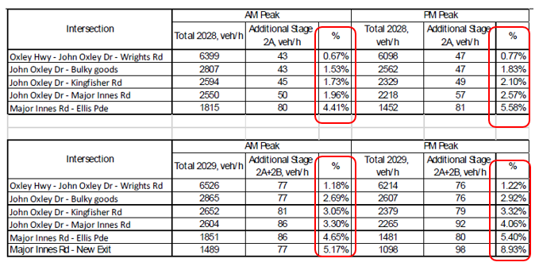

It is important to note that Council is currently working on area wide Traffic Study which includes this locality. A draft version has concluded that the projected traffic volumes are consistent between Council’s current model and TEF model.

    - The TIA did not clearly identify trips generated by the development.
TEF Consulting provided the following table to identify the trips generated by the CSU development stages, making assumptions that the new proposed access road south of Ellis Parade is expected to attract a significant proportion of CSU traffic to/from the south. This would have the effect of reducing traffic flows for the right hand turns into and left hand turns out of Ellis Parade, which would have previously have been assigned to Ellis Parade in Stage 2A TIA.

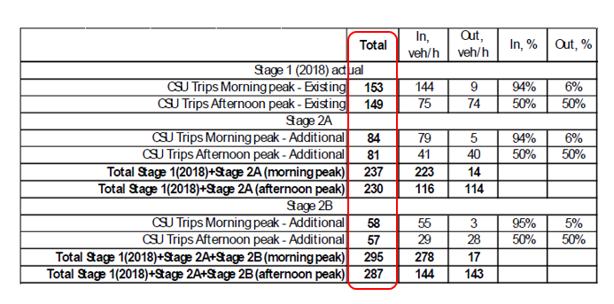
    - Modelled conditions were based on future updates to John Oxley Drive Precent Model
TEF responded that the most critical intersection for the TIA is the intersection of Major Innes Dr/Ellis Parade. This was modelled without upgrades in the TIA. In response to the Council’s request, TEF modelled the roundabout of John Oxley Drive/Major Innes Road modelled without Council’s future road improvements. Refer to extracted table below. The Base scenario in 2024 and Base scenario in 2029 was modelled without CSU stages 2A & B, assuming an annual growth of general traffic of 2.5%. The results are presented below.

The details show that The John Oxley Drive / Major Innes Rd roundabout will need to be upgraded by 2024 (based on the assumed traffic growth) regardless of further CSU development. The intersection of Major Innes Rd/Ellis Parade does not require an upgrade (it is noted that the model assumes good driver discipline with regard to the “KEEP CLEAR” restriction).

Council has received a draft of Council’s own TIA for the John Oxley Drive precinct, which would appear to be consistent with the findings of this report in terms of likely traffic volumes. Both reports identify that without future upgrades the intersections in this precinct the road functions will deteriorate to unacceptable levels of service which will result in significant delays etc for road users particularly during the peak travel periods.

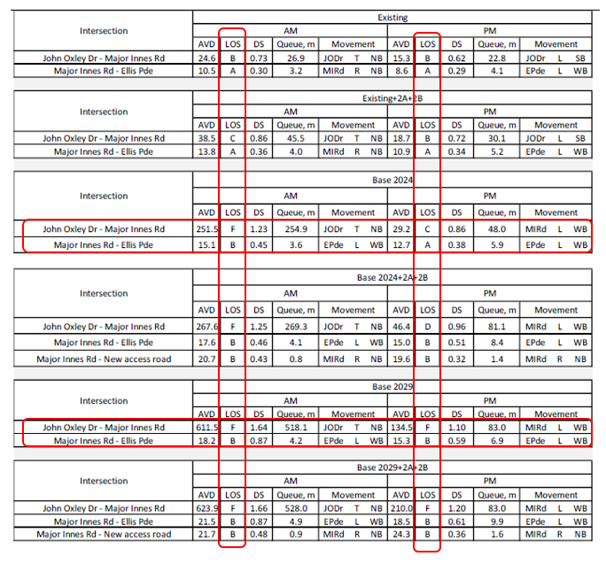
In conclusion, the assessment by Council staff has concluded agreement with TEF that the additional traffic generated by development, in comparison to the background traffic, is a small percentage of increase above overall traffic in this area. In particular it is also recognised that the level of service (LOS) of many of the intersections in the John Oxley Drive/ Major Innes precinct are deteriorating as a result of significant residential growth in this area.

Council is currently awaiting the completion of Council’s TIA for the John Oxley Drive/Major Innes precinct, for the design of future upgrades to both John Oxley drive and Major Innes Road. The results of this TIA will shape how we move forward with design of the intersections in this precinct. The concept design works for the area are well underway, and Council is ready to commence detailed design based on the findings of the TIA. The intentions is to stage the design and construction of the necessary road upgrade works over the coming years (approx. 5 -15 years).

Roads and Maritime Services (RMS)
Consistent with RMS requirements, the proposal was referred to the RMS with the following being received:

1. The development application is both a Crown Development and a Regionally Significant Development that proposes development of Stage 2B of the Charles Sturt University project. It is noted that the development is well-situated within the Port Macquarie Health and Education Precinct identified in the North Coast Regional Plan 2036. It is a significantly large development that has the potential to impact on the surrounding road network, which is both State and local infrastructure.
Roads and Maritime and Port Macquarie Hastings Council are either planning or investigating future upgrades to the road network to service the level of development proposed for the emerging precinct; and to meet the needs of the wider community. Therefore, it is extremely important that sufficient detail is provided in the development application to assist both Roads and Maritime and Council in considering present and future demand for road infrastructure.
2. Roads and Maritime provided comment on Stage 1 of the subject development by letter dated 14 April 2014; wherein a number of traffic and transport concerns were raised (see letter attached as a number of the points remain relevant today). Roads and Maritime does not appear to have been provided the opportunity to comment during assessment of Stage 2A of the development, which placed increased traffic demand onto the local and State road network.

3. Information obtained from Council pertaining to the assessment of Stage 2A identified that the Consent Authority was informed that modelling of cumulative development impacts will result in the Oxley Highway, John Oxley Drive & Wrights Road roundabout performing at a LOS F under future network conditions.
In response to ongoing urban growth in the Port Macquarie area, Roads and Maritime is currently investigating future improvements to the Oxley Highway to address demand for access to Wrights Road and Lake Road intersections during peak periods. At this time suitable upgrades to these intersections with the Oxley Highway have yet to be identified or funded. The approval of successive traffic generating developments in the emerging precinct will expedite the deterioration of intersection performance on the State road and the ability for local traffic to access the wider network during peak periods.
While it is acknowledged that Stage 2B is an extension of the approved Stage 2A and the Determining Authority may move to approved the application; Roads and Maritime recommends that consideration be given to requiring deferral of any further stages of the development until suitable upgrades of the Oxley Highway and John Oxley Drive have been both identified and funded.

4. A review of the Traffic Impact Assessment (TIA) Stage 2B identifies that the application does not include sufficient explanation or justification of the adopted baseline data or underlying parameters and assumptions to enable Roads and Maritime to form an opinion regarding the reliability of the TIA conclusion; which stated; ‘all critical intersections have substantially spare capacity, particularly after the upgrades planned by Council’. In particular, we note the following;

- The TIA Stage 2B relies on previous assessments under Stages 1 and 2A rather than providing a clear methodology and assessment on its own merit. The TIA should provide a clear explanation of baseline data and all underlying parameters adopted to inform the supporting modelling. The relevance of the adopted parameters to the stages of development, and the current and future network conditions should be established without reliance solely on historical reports.
- It is understood that modelled conditions have been based on updates to the John Oxley Drive Precinct Model. It is unclear if the adopted approach has taken into consideration the most recent land use inputs and network conditions informing recent network investigations, including the Port Macquarie Area Wide Traffic Study, Council’s Orbital Road proposal and the Oxley Highway Corridor Model. It is recommended the Consent Authority seek clarification of all input parameters used to inform modelling and justification of their continued relevance.
- The TIA does not clearly identify trips generated by the existing and proposed stages of development. We note that Council’s review of the Stage 2A TIA sought clarification of cumulative trip generation for the staged development and that additional information was tabled to inform that assessment. We recommend that the Consent Authority require further detail of trips that will be generated by all existing, proposed and future stages of development to assist in understanding the cumulative impact of trips generated on the network.
- The TIA suggests that additional traffic generated by the proposed development will be accommodated by future intersection upgrades being planned by the relevant road authorities. The TIA should clearly demonstrate how additional trips will impact existing intersection conditions prior to future upgrades. The Consent Authority should consider the likelihood of proposed trips exacerbating network conditions prior to delivery of future upgrades and whether the additional trips generated by the development warrant a proportional contribution to future network improvements.

In response to the RMS feedback, the Applicant has provided additional details that:

- The impact of CSU Stage 2A on the Oxley Highway/John Oxley Drive/Wrights Road intersection was modelled as part of the assessment of Stage 2A;
- The increase in traffic movements due to Stage 2B has been considered as part of this assessment, with the increase being identified as being negligible (less than 1% of anticipated traffic movements at the subject intersection) and well within the limits of typical daily traffic fluctuations. TEF therefore considers that the CSU traffic is much lower than the traffic volumes required to effect any change in operation at this intersection;
- CSU supports investigations by RMS in to the upgrade of the subject intersection so that the upgraded design may inform future applications for development within the Health & Education Precinct.
- With respect to Item 4, CSU has in place a general Transport Action Plan which encourages students and staff to use alternative means of transport to access its campuses. CSU is currently developing a Green Travel Plan to support the existing Action Plan. CSU is also working with Council with respect to the implementation of the Health & Education Precinct and submits that a precinct wide approach to travel would be more valuable than isolated plans. However, in the absence of a precinct wide plan at this time, it is proposed to include the following condition in the development consent: “Prior to occupation, a copy of the ‘CSU Port Macquarie Campus Green Travel Plan’ is to be provided to Council and Roads and Maritime Services.”

The above response provided by the Applicant is considered acceptable and further details addressing traffic impacts can be found above earlier under the heading “Traffic and Transport”.

Site Frontage & Access
Vehicle access to the site is proposed through a proposed private road off Major Innes Drive. Access off Major Innes Road is proposed with a CHR and an AUL into the development. The concept is assessing as being acceptable. Detailed design shall be required through a Roads Act Application. The access shall comply with AustRoads Council AUSPEC and Australian Standards, and conditions have been imposed to reflect these requirements (with particular emphasis on AustROADS Guide to Road Design Part4A Unsignalised and Signalised Intersections).
Due to the type and size of development, additional works are required to include a concrete shareway along the frontage of the works.

Pedestrian and Cycle Facilities
Pedestrian and cycle connectivity are important around university facilities to encourage alternative modes of travel and reduce car dependency. Currently there is a significant pedestrian and cycle network around the area, however some gaps currently exist along John Oxley Drive connecting the CSU campus to the Base Hospital. As part of Stage 2, CSU has offered to construct a missing link of the 2.5m wide concrete shareway along John Oxley Drive between the Major Innes roundabout and the recently completed Bunnings development works, consistent with Council’s proposed John Oxley Drive Concept Upgrade Plan. The importance of this missing link to be constructed is acknowledged and has recommended its construction with this stage.

Parking and Manoeuvring
The proposed car parking and vehicular access arrangements are described below:

- A car park comprising 88 car parking spaces (as amended nett number) to support the proposed building, including 2 accessible spaces;
- An intersection with Major Innes Road including a left turn deceleration lane into the site for southbound movements and widening on the western side of Major Innes Road to provide for a protected right turn lane in to the site for northbound movements; and
- A 7m wide private road network connecting Stage 2A and the proposed Stage 2B car park with the intersection at Major Innes Road.

As outlined in the Traffic and Parking Impact Assessment by TEF Consulting submitted with the DA, the existing CSU car park comprises 331 car parking spaces.

As part of the assessment of Stage 2A TEF identified that for the CSU Port Macquarie campus the most accurate determinant of parking demand is the amount of teaching floor space. In this regard, an assessment of the operational Stage 1 campus identified that maximum peak parking demand was equal to 12.6 spaces per 100m2 of teaching floor space and the average peak parking demand was 11.6 spaces per 100m2 of teaching floor space.

The proposed Stage 2B building will increase the gross floor area of the campus by 1,407m2, bringing the campus total to 11,971m2. The total teaching floor space provided on campus at the completion of Stage 2B (including lecture rooms, laboratories and such where students are formally taught as planned by class timetables) will increase by 654m2 from 3,311m2 to 3,965m2.

The approved parking figures for the campus at the completion of Stage 2A are as follows:
- Maximum peak parking demand for general parking areas of 419 spaces; and
- Average peak parking demand between 11am and 2pm (peak times) of 386 spaces.

At the completion of Stage 2A the campus will provide a total of 423 spaces, being an excess of 4 spaces over and above the anticipated maximum peak parking demand of 419.

For Stage 2B, the increase in parking demand to account for an additional 654m2 of teaching space is expected to be:

- Maximum peak parking demand of 83 spaces; and
- Average peak parking demand between 11am and 2pm (peak times) of 76 spaces.

As noted above, the Stage 2B car park will include 88 spaces, with 2 of those spaces to be designated as accessible. At the completion of Stage 2B the campus will include a total of 511 car parking spaces of which 9 will be accessible. This is determined to be in excess of 5 spaces over and above the expected maximum peak based upon the specialist assessment submitted by TEF.

The additional parking provision is considered acceptable and is recommended to be supported.

It should also be noted that some synergies have been created with adjoining sites (i.e. student accommodation) so as to reduce the dependency on vehicles on the site. This helps to contribute positively to the lower parking demand for the site. In addition, if parking becomes an issue in the future, there is also adequate room on the site to address through overflow parking facilities.

As detailed earlier in this report, the Applicant has also offered to implement a Green Travel Plan prior to Occupation of the development.

Water Supply Connection
Council records indicate that the development site currently has a 50mm water service.

Final water service sizing will need to be determined by a hydraulic consultant to suit the domestic and commercial components of the development, as well as fire service and backflow protection requirements in accordance with AS3500.

Detailed plans will be required to be submitted for assessment with the Section 68 application. An appropriate condition is recommended.

Sewer Connection
Council records indicate that the development site is currently connected to the 300mm sewer trunk main that runs along the eastern boundary. Detailed engineering plans are to be submitted to Council prior to construction commencing.

Detailed plans will be required to be submitted for assessment with the Section 68 application. An appropriate condition is recommended.

Stormwater
The site naturally grades towards the southeast, where flows are conveyed by an existing downstream stormwater channel to the Lake Innes Nature Reserve.

To ensure that the proposal results in no downstream impacts, Council’s AUSPEC requirements specify that a development of this type/location include both on-site stormwater detention facilities to slow the rate of discharge to pre-development rates, and water quality controls, designed to achieve specified pollutant reduction targets.

A stormwater drainage plan and detailed civil engineering report has been submitted in support of the proposed development and includes the following features:
- On-site stormwater detention has been provided to maintain pre-development flow rates. The modelled pre-developed scenario has assumed that the pre-development case is a ‘greenfield’ scenario, resulting in compliance in this regard.
- The OSD facilities to service the development are provided via both continued use of the existing detention basin (with upgrades) and a new detention basin to the south-east of the site.
- Detailed modelling has been submitted to justify the size and configuration of the detention systems proposed.
- Stormwater runoff from the site is proposed to be treated within a series of bioswales located within landscaped areas that will be collected and discharged to the grassed swale leading to the proposed detention bund to the south-east.
- Modelling of these systems (in conjunction with the existing infrastructure already within the site) demonstrates that the proposal exceeds Council’s requirements in this regard.

A detailed site stormwater management plan will be required to be submitted for assessment with the Section 68 application and prior to construction commencing. Appropriate conditions are recommended in this regard.

Other Utilities
Telecommunication and electricity services are available to the site. A standard condition recommended to require the proponent to provide any upgrades to utilities as necessary.

Heritage
Following a site inspection (and a search of Council records), no known items of Aboriginal or European heritage significance exist on the property. Aboriginal Heritage Information Management System searches undertaken by the Applicant for the site did not reveal any known items of Aboriginal significance. No adverse impacts are anticipated.

Other land resources
The site is within an established urban context and will not sterilise any significant mineral or agricultural resource given future planning for the precinct.

Water cycle
The proposed development will be unlikely to have any adverse impacts on water resources and the water cycle.

Soils
The proposed development will be unlikely to have any adverse impacts on soils in terms of quality, erosion, stability and/or productivity subject to a standard condition requiring erosion and sediment controls to be in place prior to and during construction.

Air and microclimate
The construction and/or operations of the proposed development will be unlikely to result in any adverse impacts on the existing air quality or result in any pollution. A standard precautionary site management condition is recommended.

Flora and fauna
The Applicant has submitted a specialist Flora and Fauna Assessment prepared by SLR Consulting to consider the potential ecological impacts of the proposed development.

The SLR report has been reviewed by Council staff who have concluded that construction of the proposed development will not require any removal/clearing of any significant vegetation and together with the proposed offset areas to be managed will therefore will be unlikely to have any significant adverse impacts on biodiversity or threatened species of flora and fauna. Part 7 of the Biodiversity Conservation Act is considered to be satisfied.

Waste
Satisfactory arrangements are in place for proposed storage and collection of waste and recyclables. No adverse impacts anticipated. Standard precautionary site management condition is recommended.

Energy
The proposal includes measures to address energy efficiency and will be required to comply with the requirements of Section J of the Building Code of Australia. No adverse impacts anticipated.

Noise and vibration
The Applicant has submitted a specialist noise impact assessment prepared by WSP Australia Pty Ltd (WSP). The assessment has been prepared in accordance with the Council’s Development Control Plan, the NSW Noise Policy for Industry and the NSW Road Noise Policy.

WSP identify that as a result of the existing traffic along Major Innes Road and a comparatively minor predicted increase in traffic volume resulting from Stage 2B, the overall acoustic environment is anticipated not to be impacted by the increase of road traffic. The impact to the residential receivers adjacent the site will therefore be negligible.

WSP’s assessment confirms that the environmental noise emissions from the car park, waste collection, pedestrian traffic, and operational road traffic have been addressed. However, as the development is in the early design stages a detailed environmental noise emissions assessment has not been undertaken.

WSP recommend that during the detailed design phase that the proposed development be designed to achieve compliance with the applicable environmental noise limits. The location of mechanical plant on the eastern side of the building’s roof is supported by WSP. Subject to the implementation of suitable acoustic treatments WSP identify that compliance with the relevant criteria will be achievable.

No adverse impacts anticipated. Conditions are recommended to restrict construction to standard construction hours and a requirement to comply with the recommendations of the WSP report.

Bushfire
The land is mapped as being bushfire prone, however, it is noted that the Bushfire Prone Land mapping does not reflect recent changes to the vegetation in this location, including the vegetation removal associated with Stages 1 and 2B of CSU and the adjoining Student Accommodation development. It is also noted that some of the completed vegetation removal has changed the bushfire status of some of the vegetation in this location.

The Applicant has submitted a specialist bushfire report prepared by BlackAsh Bushfire Consulting.

Blackash note that the NSW Rural Fire Service (RFS) is currently in the process of reviewing Planning for Bushfire Protection 2006 (PBP 2006). The RFS has released a new version of the document known as Planning for Bushfire Protection 2018 (PBP 2018), however, this version is yet to be formally adopted.
In order to demonstrate compliance with PBP 2006, Blackash has assessed the proposed development against the provisions of PBP 2018 as is represents the most current approach to bushfire planning.

Under the current legislative provisions, a tertiary education development which does not include student or staff accommodation is not categorised as a Special Fire Protection Purpose (SFPP) under Section 100B of the Rural Fires Act 1997. As such, the development is considered to not be Integrated Development under the provisions of Section 4.46 of the Environmental Planning and Assessment Act
1979.

However, under the provisions of PBP 2018, universities are identified as being SFPP. As such, whilst this application is not formally identified as being Integrated Development at this time, it has been assessed under the provisions of PBP 2018 to ensure that it is capable of meeting those requirements.

The predominant vegetation is classified by Blackash as low-hazard (remnant corridor) to the north and a combination of managed and forested wetland (Swamp Mahogany/Forest) to the east. The land to the south and west is considered managed land.

Blackash note that the proposed building is able to meet the requirements of PBP 2018 and have provided the following recommendations:

- Construction Standard: The proposed new Stage 2B development shall be constructed to a minimum standard of BAL 12.5 in accordance with AS3959, 2009 ‘Construction of Buildings in Bushfire Prone Areas’ and Section A3.7 of the NSW Rural Fire Service Addendum to Appendix 3 of ‘Planning for Bushfire Protection 2006’.
- Asset Protection Zones: At the commencement of building works and in perpetuity, Asset Protection Zones shall be established and maintained to the eastern forested wetland (Swamp Mahogany) interface. These APZs shall be established and maintained as an inner protection area as outlined within PBP and the NSW RFS document ‘Standards for Asset Protection Zones’.
- Access Arrangements: New access roads are to be designed and constructed in accordance with the aims and objectives of PBP, and as per the internal access road requirements of PBP section 4.2.7, as per section 9 and Table 3 of the Blackash report.
- Water Supplies: New water supply networks are to be designed and constructed in accordance with the aim and objectives of PBP, and as per AS 2419:2005.
- Services: Any gas services are to be installed and maintained in accordance with Australian Standards AS/NZS 1596 “The storage and handling of LP Gas” (Standards Australia 2008).
- Updated Emergency Plan: Prior to occupation an updated emergency management plan.

A standard condition is recommended to require compliance with the Blackash report recommendations in this regard.

Social and Economic impacts in the locality
A Social Impact Comment was submitted as a part of the Stage 1 Development Application (January 2014) which established the campus on the land. The comment determined that the potential social impacts of the campus were considered to be of a minor nature. This was based on the fact that the university provides opportunities for tertiary education and generates increased demand for retail, recreation and community facilities in the local community.

Council’s Urban Growth Management Strategy identifies the CSU campus as being within a Health and Education Precinct and recognises the campuses expected growth.

The UGMS states ‘…the new campus of Charles Sturt University (CSU) in Port Macquarie is planned to expand to service around 5,000 equivalent full time students by 2036. The growth of the health and education sectors presents an opportunity to increase the number of young people in our community, diversify our economy, increase labour force participation and build on Port Macquarie’s growing status as a regional city’.

The proposed expansion of the university campus is likely to generate a significant positive impact on the socio-economic environment of the Port Macquarie-Hastings region. In support of this statement recent economic impact modelling of the Port Macquarie campus has estimated that CSU contributes the following:
- 0.5% of gross regional product;
- 0.5% of household income;
- 0.5% of full-time equivalent employment in the Port Macquarie-Hastings;
- Campus operations generated the largest contribution to full-time equivalent employment in the Port Macquarie-Hastings region at 77.1% of the overall employment impacts;
- Student expenditure, the second largest contributor to full-time equivalent employment, made up 20.5% of the overall full-time equivalent impact (note that this does not include the economic impact expenditure by internal local students attending the Port Macquarie campus); and
- 513 students studied internally at the Port Macquarie campus in 2016, of which 242 (47%) were local.

Prior to the university’s opening in 2016, the Council’s Community Profile data identified the Port Macquarie-Hastings region (13.4%) as being below the regional (14.5%) and state (23.4%) averages for tertiary level education. The region was also identified as having a below average population between the ages of 15 to 19 and 20 to 24. The continued expansion of the campus as proposed, is considered to ensure that the Port Macquarie-Hastings improves the number of tertiary educated persons as well as those of a typical university age (17-24).

Given the nature of the proposed development and its’ location the proposal is unlikely to result in any adverse social impacts.

A likely positive impact will also be that the development will maintain employment in the construction industry, which will lead to flow impacts such as expenditure in the area.

Site design and internal design
The proposed development design satisfactorily responds to the site attributes and will fit into the locality. No adverse impacts likely.

Construction
No potential adverse impacts identified to neighbouring properties with the construction of the proposal. Standard site management condition requirements are recommended.

Cumulative impacts
The proposed development is not expected to have any adverse cumulative impacts on the natural or built environment or the social and economic attributes of the locality.

(c) The suitability of the site for the development
The proposal will fit into the locality and the site attributes are conducive to the proposed development.

Site constraints of bushfire risk, flooding and potential land fill gas migration on the site have been adequately addressed and appropriate conditions of consent recommended where required.

(d) Any submissions made in accordance with this Act or the regulations
One (1) written submission has been received following public exhibition of the application.

Council’s received this submission as a late submission from the Hastings Birdwatchers. The submission from the Hastings Birdwatchers relates to the removal of five (5) isolated paddock trees. It is noted that the removal of the subject trees has been assessed separately to the Stage 2B development application and has formed part of a modification to the Stage 2A development consent. As such, the removal of the subject trees no longer forms part of this application.

However, the following is noted with respect to the consideration given to the removal of vegetation:

- As part of Stage 1 of the campus, CSU implemented a Vegetation Management Plan (VMP) for the site. The VMP was prepared by site ecologists, SLR, and considered the vegetation removal associated with Stage 1 and future stages. The VMP included the establishment of an offset area being 3.59Ha in size. The offset area has been established on the land and is actively being regenerated by local bush regeneration contractors Wild Things Native Gardens;
- The removal of the subject trees has more recently been assessed by site ecologists, SLR, in its recent Flora & Fauna Assessment Report. That report has concluded that:
“Due to the minor scale of the proposed works, and the low importance of the habitat to be removed, the proposed development is of little to no
relevance with respect to the life cycles and habitat requirements of
any threatened species, migratory species or communities listed under
the EPBC Act.”

Based upon the above the submission issues raised have been satisfactorily addressed.

(e) The public interest
The continued expansion of the campus in the appropriate manner proposed is considered to ensure that the Port Macquarie-Hastings improves the availability of tertiary education.

The proposed campus expansion will offer appropriate increased opportunities for tertiary education by improving course options as well as further demand for retail, recreation and community facilities in the local community.

The proposed development satisfies relevant planning controls as justified and will not adversely impact on the wider public interest.

Climate change
With regard to potential climate change impacts relating to flooding, refer to comments provided earlier in this report under Port Macquarie-Hastings LEP addressing climate change.

4. DEVELOPMENT CONTRIBUTIONS APPLICABLE
Section 94 Contributions
No - The development does not involve the creation of an additional residential component.

Section 7.12 Contributions
Yes - The development contains commercial components however the Applicant on behalf of the Crown/CSU has proposed to not accept a development contributions condition. The Applicant has advised that CSU is currently considering its options to provide public facilities in the area.

The Applicant has advised that they are investigating a pedestrian/cycleway link connecting from Kingfisher Road to CSU however this will need further investigation and assessment.

Section 64 Water and Sewer Contributions
Yes – Condition recommended and agreed to by Applicant on behalf of Crown. An estimate of Notice of Payment is attached to this report.

5. CONCLUSION AND STATEMENT OF REASON
The application has been assessed in accordance with Section 4.15 of the Environmental Planning and Assessment Act 1979.

Issues raised during assessment have been considered in the assessment of the application. Where relevant, conditions have been recommended to manage the impacts attributed to these issues.

The site is considered suitable for the proposed development and the proposal adequately addresses relevant planning controls. The development is not considered to be contrary to the public's interest and will not result a significant adverse social, environmental or economic impact. It is recommended that the application be approved, subject to the recommended conditions of consent provided in the attachment section of this report.

